Packet 1 - Basic Board Information BMHOA
General Homeowners Association Facts Overall
- 351,000 HOA’s in the United States
- 53% Homeowning Americans live under a HOA
- $250.00/mo average fee for a single-family home
- 70% of all HOA’s are managed by volunteers
- Homes within HOA average 4% higher price than those without
Specific to Our Association
Blaire Meadows Homeowners Association (BMHOA) provides regulations and guidelines for its members. These standards are set forth with the goal of preserving and enhancing this sub-divisions property values. We rely on the Declarations of Restrictions of Blaire Meadows Subdivision created on November 15, 1994 by Blaire Meadows Venture.
This Declaration of Restrictions recorded with Macomb County Register of Deeds February 2, 1995.
We are also on file with Michigan Department of Licensing and Regulatory Affairs (LARA) as a Domestic Nonprofit Corporation. Identifier # 800943095 and runs as a perpetual term.
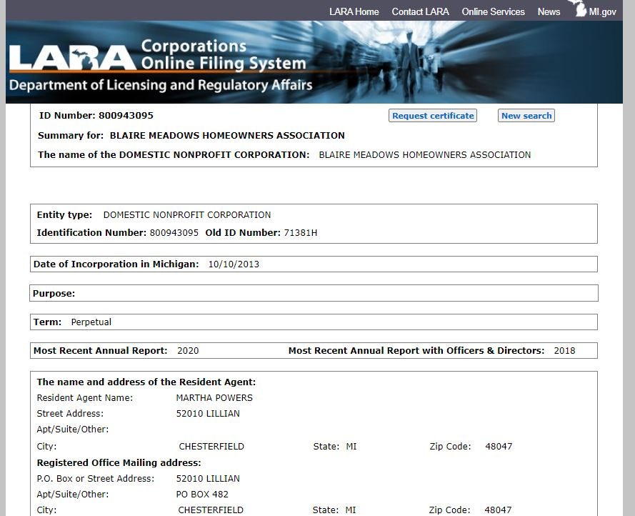

BMHOA has a total of 100 homes within our association. Each home is required to be part of this association and is referred to as “Mandatory Membership” when speaking HOA language.
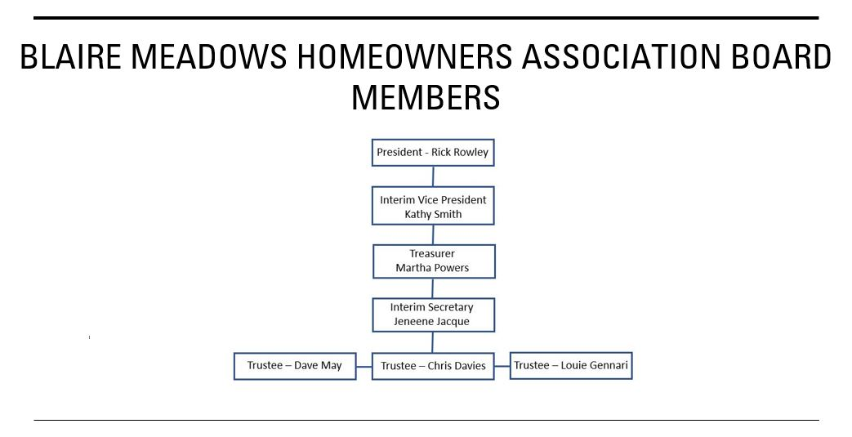
BMHOA Board 2/16/21
Three general responsibilities of BMHOA board. Maintaining common areas, managing budgets/fiscal responsibilities, and enforcing/complying with governing documents.
There are two means available of managing BMHOA:
- Professional property managers
- Self-governance by residents either by being elected or volunteered
BMHOA board has been a Self-governance body since day one. Easy to admit the idea that the best people to manage a community are the people living in it vs paying exuberant fees to a management company.
HOA boards usually consist of three to seven members. Associations are required to have a president, secretary, and treasurer at a minimum. Regardless of the number of board members the total involved must remain at an odd number. This eliminates the possibility of a tie if a vote is ever needed while conducting business.
Seven residents make up our board and not compensated in any way. All have volunteered their time to sit on this board and has been this way since the beginning of BMHOA.
Any board member may resign if they so wish if they give written notice to the rest of the board. The board can also remove any member with or without cause at any time.
In these instances of a vacancy, the board can appoint a replacement with a majority vote.
Please understand that no position sits idle for the simple reason of a board member resigning or any other reason. This would disrupt board business.
Our declaration states these positions are meant as a “Two Year Term” whereas elections may be held for any resident interested in being part of this board. Unfortunately, no resident has ever expressed interest in becoming a candidate for any seat throughout the 26-year history of Blaire Meadows. Simply put, how can there be an election if there are no candidates? This is quite common in self-governed associations, so we are not out of the “norm” with this subject. Comforting to know as we are a group of volunteers doing the best we can.
With all board members volunteering together we act to the best of our ability following federal, state, and local laws as required. At times we turn to our attorney for guidance and clarification on certain items. Fortunately for us this attorney, Jim Novara, from Ruggirello, Velardo, Novara, Ver Beek, Burke & Reizen, P.C. is a member of BMHOA. We are thankful, as all residents should be, that Jim has saved our association a substantial amount of money over the years by spending time with various board members, when the need arises, all free of charge. Please make note when this board requires legal documents and filings this firm is compensated for their efforts as is expected.
Our board meets on average of four times throughout any given year with the exception in 2020. A membership meeting referred to as “Annual Townhall” has been provided yearly within the month of May with a revised date of October once again 2020.
Responsibilities of Board Member by Title
President:
- Most of the time acting as facilitator and communicator among the other board members.
- Does not make decisions on his/her own.
- Presides over meetings while making sure all members of the board have the opportunity to give their opinions.
- Decisions are made only after appropriate discussion and with the best interests of the community in mind.
- Responsible for preparing meeting agendas and ensuring all important undertakings are accomplished.
Vice President:
- Mainly supports the president.
- Stands in for president in meetings/functions president cannot attend.
- Serves as a chairman of a committee when the need arises.
Secretary:
- Responsible for all association records.
- Delivers notice of meetings.
- Records minutes.
- Sends out annual newsletter.

Treasurer:
- Responsible for all financial transactions of the association, both incoming and outgoing.
- Creates and collects annual dues.
- Communicates with attorney regrading liens when they are placed.
- Issues payments to vendors as needed and approved by the board.
- Provides annual budget and income/expenditure report for this board and the membership.
- Provides documentation as requested by residents, realtors, and title companies relating to financials.
Trustee:
- Participate in discussions and assists with decision making.
- Supports the executive board with tasks at all levels.
- Can serve as a chairman of a committee when the need arises.
Membership Dues
This topic becomes the easiest to understand and simply “Black and White” as all funds are accounted for. As in all HOA’s the main priority focuses on the common areas. This entails maintenance, improvements, insurance, and utilities. Granted most of the monies go towards these and there are other expenditures that add up just as quick. Case in point the simple task of mailing out our yearly dues, in combination with the newsletter, and budget spreadsheet runs $117.00 at a minimum. The list goes on and as always, the budgetary spreadsheet has been handed out to those attending our “Townhall” meeting and readily available for all to receive by contacting our treasurer at blairemeadows@gmail.com

Short and sweet and we sincerely hope that this helps you to better understand the workings of BMHOA board. Never hesitate to contact us if you have any concerns or questions. Visit www.blairemeadows.com for further information.

Resources
Homeowners Protection Bureau, LLC (HOPB) ~ We Help Build Stronger Communities One Homeowner at a Time
iProperty Management ~ HOA Statistics
IKO Community Management ~ 13 Statistics About HOA Communities That Will Make You Proud (September 5, 2019)
Investopedia ~ Homeowner Association (July 4, 2020)
Cedar Management Group ~ Functions of HOA Board of Directors
Thayer & Associates, Inc, AMO ~ The Responsibilities of HOA Board Members (January 8,2020)
State of Michigan ~ Michigan Department of Licensing and Regulatory Affairs (LARA)

